- 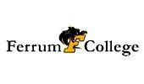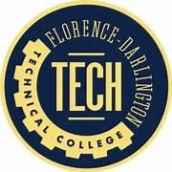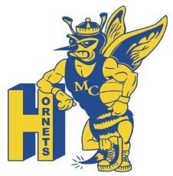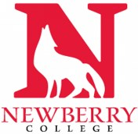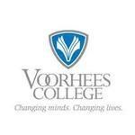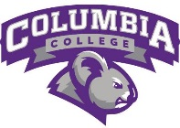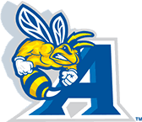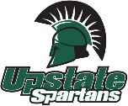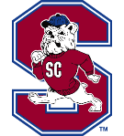

DILLON HIGH SCHOOL
2019 SENIOR COLLEGE ACCEPTANCE LIST
Aiken Technical College | Shaniah T. Brown
Allen University
Anderson University | Annette Habonimana
Averett University
Barton College | Colby Watts
Benedict College
Bennett College | Joelisha C. Blue
Bethune-Cookman University | Damiah Breeden
Carleton College
Charleston Southern University | Nancy L. Hodge  Raymond Y. Hodge
Claflin University | Qy’Tasia smith
Clemson University
Coastal Carolina University | Annette Habonimana
Coker College | Mariah Owens  Colby Watts  Joelisha Blue  Jade McDowell  Annette Habonimana
College of Charleston | Jacqueline Reaves
Columbia College | Jacqueline Reaves
Delaware State University | Joelisha Blue
East Carolina University | Jacqueline Reaves
Ferrum College
Florence- Darlington Technical College | Dyshania S. McMillan  Qy”tasia Smith
Florida Atlantic University | Jacqueline Reaves
Francis Marion University | LaTaurean T. Brigman  Mariah Owens  Deonte Godfray  Raymond Hodge  Qy’Tasia Smith
Furman University
Hawai’I Pacific University | Jacqueline Reaves
Lander University | Sandy A. Bullock  Annette Habonimana
Limestone College | Shania Brown
Livingstone College | Joelisha C. Blue
Neumont College of Computer Science | Domminik Gest
Norfolk State University | Joelisha Blue  Kezia Dentley
Newberry College | Colby M. Watts  Jasmine Gillespie
Northeastern Technical College
Presbyterian College
Savannah State University
Shaw University | Arreonna Terry
South Carolina State University
Southern Wesleyan University | Annette Habonimana
Tennessee State University | Damiah Breeden  Shobria Sowells
Texas Southern University | Damiah Breeden
University of Iowa
University of Northern Iowa | Nagee Murphy
University of South Carolina
University of South Carolina at Union
University of South Carolina Upstate
Virginia State University | Joelisha Blue
Voorhees College
Wingate University
Winthrop University | Damiah L. Breeden  Annette Habonimana  Christopher J. Murray
Wofford
Worcester Polytechnic Institute

